Face Detection and Recognition
Abhinav Jindal, Shrey Gera, Pallav Semwal, Shivam Kansal, Aniket Sood, Vaibhav Rohaan, Arihant Jain
Under the guidance of Mr.Manoj Kumar Singha

Abstract—The face is one of the easiest approaches to distinguish the character identity of each other. Face Recognition is a private identity system that uses private traits of a person to become aware of the man or woman's identification. Human face recognition essentially consists of two phases, the first being face detection, where this process is quite rapid for humans, except for the conditions in which the object is positioned at a brief distance away, and the next type of phase being the introduction, which understands a face as individuals. The Stage is then replicated and advanced as a model for facial image recognition (face recognition) which is one of the more-studied biometrics technologies and has evolved by means of professional trials and development by experts. The computational approach taken in this system is motivated by both physiology and information theory as well as by the practical requirements of near real time performance and accuracy. The software requirements for this task is MATLAB software.

Introduction
Major aspects of the project are face detection and recognizing that while people tend to confuse one problem with another, they have a defined purpose and their own set of validation algorithms.
FACE RECOGNITION: Face recognition is a task of identifying an already detected object, it decides whether a face is known or unknown. On the other hand, Face detection involves separating images into two classes; one containing the faces and other the background, helping to distinguish if the object can be classified as a face object. Recognition algorithms can be divided into main approaches:
- Geometric: It is based on spatial configuration of facial features. It basically means it tries to locate main geometric features like eyes, nose and mouth and then classify them on the basis of angles and distances.

- Photometric stereo: The shape is recovered from a number of images taken under different lighting conditions defined by a gradient map, which is made up of an array of surface normal.

- Some popular recognition algorithm include:
  - Principal Component Analysis.
  - Linear Discriminate Analysis.
  - Elastic bunch graph matching using the Fisherface algorithm.

FACE DETECTION: In an ideal face detection model, a detector would be able to detect any face in presence of any set of lighting conditions, background or any partial occlusion and disguise. The face detection system can be divided into following steps:
- Pre-processing: To reduce the variability, all positive examples are obtained by cropping images which are then corrected for lighting through standard algorithms.

- Classification: Neutral networks are used to classify images as faces and non-faces by training on examples.

- Localization: The trained neural network is then used to search for faces in an image and if present localize the in bounding box.

There are two styles of techniques which are currently popular in advanced face recognition patterns namely, Eigenface method and Fisherface technique. Facial image recognition Eigenface method is based on the reduction of face-dimensional space making use of the Principal Component Analysis (PCA) for facial feature recognition. The principal reason of the use of PCA on face popularity using Eigenfaces was formed (face space) via locating the eigenvector similar to the biggest eigenvalue of the face image. PCA (Principal Component Analysis) is a dimensionality reduction technique that was proposed by Pearson in 1901. It uses Eigenvalues and Eigen Vectors to reduce dimensionality and project a training sample/data on small feature space. The significant features are known as “eigenfaces”, because they are eigenvectors or principal components of the set of faces. The vicinity of this project's face detection system with face recognition is Image processing. Fisherface is also a popular algorithm used for face recognition. Image recognition using fisherface method is based on the reduction of face space dimension using Principal Component Analysis (PCA) method, then applying Fisher's Linear Discriminant (FDL) method or also known as Linear Discriminant Analysis (LDA) method to obtain feature of image characteristics. The Eigenface technique, another method based on linearly projecting the image space to a low dimensional subspace, has similar computational requirements.

Digital Image Processing
Digital Image Processing finds its application in various day-to-day industries and fields. Examples include automatic character recognition, industrial machine vision for product assembly and testing, military recognition, automatic processing of fingerprints etc.

Image: An image refers to the performance of a 2D light f (x, y), where (x, y) defines the local coordinates with the value of f at any time (x, y) equal to the brightness or Gray levels of the image at that point. A digital image is a f (x, y) image that is both fixed in relation to space and light. The elements of the same digital elements are called image elements or pixels.
Simple image model: For computer processing, the image f(x, y) must be digital both geographically and amplitude. The digital input of the local link (x, y) is called the image sampling. Performing Amplitude digitization is called Gray-level quantization.
The storage and processing requirements are growing rapidly with local solutions and a number of Gray levels. Example: A grayscale image of size 256x256 takes up to 64kb memory.
Types of image processing:
- Low level processing: Low-level processing means making basic operations in images such as learning to resize an image, resize, rotate an image, convert RGB to Gray, histogram equalization, etc.
- Medium level processing: Medium-level processing means removing regions of interest from the output of a low-level processed image. Medium-level processing is about determining boundaries i.e., edges. This process is called segmentation.
- High level processing: High-level processing works by adding artificial intelligence to the medium level processed signal.
Fundamental steps in Digital Image Processing-
1. Photo capture: digital photo acquisition
2. Pre-image processing: image enhancement in ways that increase the chances of success in other processes.
3. Image segmentation: separating an image to insert into its elements.
4. Image classification: converting input data into computer-ready mode.
5. Image description: extracting elements that lead to certain interesting information of the basic elements of distinguishing one category of objects from another.
6. Image recognition: assigning a label to an object based on information provided by its description.

Experimental approaches
Over the last few decades, many approaches have been proposed for face recognition. Almost all of the recent approaches to the face recognition problem, unlike the approaches proposed during the early stages of computer vision, have been creditable. According to the research done by the scientists, Brunelli and Poggio (1993), all approaches to human face recognition can be divided into two strategies or ways:
Geometric feature matching: This approach considers computation of geometrical features such as nose width and length, mouth position, chin shape, etc. from the picture of the face to be recognized. The set of features is then matched with the features of known individuals. An appropriate technique, like Euclidean distance (finding the closest vector) can be used to find the closest match.

The advantage of this approach is that face recognition is possible even at very low resolutions and with images with many ruptured pixel intensities. Meanwhile, the face cannot be viewed in detail, the overall geometrical configuration can be extracted for recognition of the face. Disadvantage of the approach is that automatic extraction of the geometrical features of the face is very hard. Automated geometrical feature extraction-based recognition is very sensitive to the scaling and rotation of a face in the image plane.

Template matching: This is similar to the template matching technique used in face detection. But here the goal is not to classify an image as a 'face' or 'non-face' but to recognize a face. Whole face, eyes, nose and mouth regions could be used in a template matching strategy. The basis of the template matching approach is to extract whole facial regions (matrix of pixels) and then match these with the stored images of known individuals. Here also, the Euclidean distance method can be used to find the closest match. There are more complicated methods of template matching. These methods involve much complicated prior processing and transformation of grey-level intensity values which are extracted. Out of the many template matching techniques, Principal Component Analysis was chosen because it proved to be highly reliable in pattern recognition tasks and is relatively simple to implement.

An investigation of both the approaches for face recognition by Brunelli and Poggio (1993) came to the conclusion that a feature-based strategy can offer smaller memory requirements and higher recognition speed, but template-based techniques offer better recognition accuracy.

Applications
The mоst suitаble reаl-wоrld аррliсаtiоns fоr fасe detection аnd recognition systems аre:

Mugshot Matching: А mugshоt is а рiсture оf аn individuаl frоm the shоulders uр, usuаlly tаken аfter аn individuаl is аrrested. The imрlemented mаnuаl fасe deteсtiоn аnd аutоmаted reсоgnitiоn system is ideаl fоr mugshоt mаtсhing. Sinсe соntrоlled соnditiоns аre рresent when mugshоts аre gаthered, the frоntаl view fасe reсоgnitiоn sсheme shоuld disрlаy а reсоgnitiоn ассurасy fаr better thаn the results.

Surveillance: The fully аutоmаted fасe deteсtiоn аnd reсоgnitiоn system (with аn eye deteсtiоn system) соuld be used fоr simрle surveillаnсe аррliсаtiоns suсh аs АTM user seсurity.

Ассess соntrоl: Biоmetriс Ассess Соntrоl Fасe mаtсhing саn be integrаted аs а high seсurity раsswоrd yоu саn’t fоrget. Eаsy tо remember раsswоrds аre соnvenient yet аlsо eаsily hасkаble. Соmрlex lоgin сredentiаls whiсh vаry with every ассоunt аre mоre seсure but highly diffiсult tо mаnаge.

Fасe ID: The fасe deteсtiоn рrосess is аn essentiаl steр аs it deteсts аnd lосаtes humаn fасes in imаges аnd videоs. It is а wаy оf reсоgnizing а humаn fасe thrоugh teсhnоlоgy.

Humаn Соmрuter Interасtiоn: This рrосess is bаsed оn fасe deteсtiоn. Аn imроrtаnt аsрeсt in this рrосess is sight trасking. Thrоugh the line оf sight trасking, the user's fосus саn be eаsily оbserved, whiсh is mоre соnduсive tо аnаlyzing the user's аreа оf interest аnd аnаlyzing the user's сhоiсes and рreferenсes.

Lаw Enfоrсement: Lаw enfоrсement оffiсers саn use mоbile deviсes tо сарture fасe reсоgnitiоn-ready рhоtоgrарhs оf рeорle they stор оn the street, surveillаnсe саmerаs bоаst reаl-time fасe sсаnning аnd identifiсаtiоn сараbilities. The federаl, stаte, аnd lосаl lаw enfоrсement аgenсies hаve ассess tо hundreds оf milliоns оf imаges оf fасes оf lаw-аbiding сitizens.

Sоme оther аррliсаtiоns оf fасe deteсtiоn inсlude multimediа mаnаgement, smаrt саrds, fасe dаtаbаse etс.

Algorithm Used
The 2 steps dealt with in the paper were face detection and face recognition:

Face Detection
The algorithm used for face detection is the Viola Jones algorithm, named after two computer vision researchers Paul Viola and Michael Jones in their paper, “Rapid object Detection using a Boosted Cascade of Simple Features”, proposed in 2001.

Despite such a long time this algorithm is still in real time application contributing to the trade-off with its speed and accuracy. Though the algorithm is very slow to train but can detect faces in real time with impressive speed.

Working
This algorithm works on grayscale image, and has four main steps namely:
- Selecting Haar-like features.
- Creating an integral image
- Running AdaBoost training
- Creating classifier cascades.

Haar-Like Features
This concept of Haar wavelets, was given by a Hungarian mathematician, Alfred Haar, which are a sequence of rescaled ‘square shaped’ functions which together form a wavelet family. Viola Jones adapted the idea of using Haar wavelets and developed the Haar Like features.

These features are digital image features used in object recognition here the object being the face. All human faces share some universal properties like the eye region is darker than its neighbouring regions, and the nose region is brighter than the eye region. A simple way to find out which region is lighter or darker is to take the summation of pixel values of both regions and compare them accordingly. The summation of a darker region will be smaller than those in the lighter region.

These relatively darker and lighter regions were used to interpret as nose or eyes depending on the comparison and when trained on enough dataset can interpret the different parts of a face then these proved to be quite impressive.
Viola and Jones identified 3 types of features in their research - Edge features, Line features and Four-sided features.

To be beneficial, Haar-like features need to give a large value of the difference of pixels, which demonstrates that the areas in the white and black rectangles are different. These features perform well for detection of human faces.

Integral Images
Performing the calculation of Haar-like features on all the pixels by brute force is very time consuming because these calculations can be very intensive since the number of pixels will be much greater when we are dealing with a large feature/image, the integral image allows us to perform these calculations quickly so that we can easily understand whether a feature of several pixels fits the criteria.

An integral image, also known as a summed-area table, is both a data structure and an algorithm. It is a quick and efficient way to calculate the sum of pixel values in an image or rectangular part of an image. In an integral image, the value at each point is the sum of all the pixels that are above and at the left, including the target pixel.

In an integral image, the value in each cell of the matrix is the sum of all pixels above and to the left, including the target pixel. Using this integral image data structure, we can save a lot of time for calculating the summation of all the pixels in a rectangle as we only have to perform calculations on four edges of the rectangle. Now to calculate the value of any haar-like feature, we have a simple way to calculate the difference between the sums of pixel values of two rectangles.

AdaBoost
AdaBoost is a Machine Learning algorithm we use in the Viola Jones Algorithm but why do we need it?

This is due to the number of features that are present in a 24x24 matrix of pixels which is nearly 160,000, but only a few features are important to identify a face. So, we use the AdaBoost algorithm to identify and use only the best features out of the total features. Basically, it is a selector ml algorithm for selecting the best features so as to reduce the complexity of the algorithm and make it fast. Some subregions produce strong responses to the classifier. It gives us a strong classifier by multiplying constants/weights to weak classifiers to assign weights/superiority among features and grouping them into a single strong classifier.
The result is a strong classifier or a boosted classifier, that contains the best performing weak classifiers in a group.

Cascading Classifiers
We don’t just bombard all the test data by all the strong features which we extract from the training data and after passing it through AdaBoost training because even after AdaBoost training, the number of best features range around 3000, and it is still a lengthy computation and time-consuming process to calculate the outcome for each region.
So instead focusing on the features which will result in a face detection, the job of cascade is to quickly discard non-faces, and avoid wasting time and computations.

We do so by cascading the system into multiple stages which is a cluster of features and acts as different classifiers. We check stage by stage, first checking with the help of best features, such as the one that identifies eyes, nose and such.

Face Recognition

Convolutional Neural Network:-
CNN is a neural network with convolutional layers. It contains two types of hidden layers, i.e., convolutional layers and pooling layers, which are placed alternately in the neural network.

CNNs are a type of neural networks that specializes in image processing. The layers of Convolutional Neural Networks are composed of 4 types of layers:
- A Convolutional Layer captures patterns in the image by running its representative matrix through a set of learnable filters that represent different visual features in the image. These filters slide over the image based on a specified number of pixels. In each of the convolutions the filters produce their own feature map; the final output of this layer is a transformation of the original image, consisting of all the feature maps stacked on top of each other.
- The ReLU i.e., Rectified Linear Unit Layer, is a non-linear activation function f(x) = max(x,0). It transforms the elements of the output of the convolutional layer, from 0 to infinity, without changing its shape.
- A Pooling Layer down samples along the dimensions of the image, reducing the size of the image representation. By reducing the number of features in the CNN, the model increases its computational efficiency while retaining most of the defining features of the images.
- Fully-Connected Layer. While the convolutional layer makes local connections, each node in a Fully-Connected Layer is connected to all nodes in the previous layer.

AlexNet
It is the first prominent model to incorporate the CNN. AlexNet has been trained on over a million images and the architecture of AlexNet contains 60,000 total parameters within 8 total layers: 5 convolutional layers, and 3 fully connected layers. The network has the image input size of 227 x 227.

Transfer Learning
Transfer learning is the method of effectively transferring the learning from one model to another often used for models required for smaller datasets. Some of the ways to apply transfer learning depends on different factors such as size of dataset, computational resources.

We choose a pre-trained network and use it as an initial point to learn a new task. Much easier and faster way is to fine-tune a network with transfer learning instead of training it with randomly initialized weights from scratch. We can quickly transfer learnt features to a new task using a smaller number of training images.

Codes
Following are the codes which need to be implemented for Face Detection and Recognition:

- Train_model.m

% using alexnet network
warning off
g = alexnet;
layers = g.Layers;
layers(23) = fullyConnectedLayer(4);
layers(25) = classificationLayer;
allImages = imageDatastore('dataset','IncludeSubfolders',true,'LabelSource','foldernames');
options = trainingOptions('sgdm','InitialLearnRate',0.001,'MaxEpochs',25,'MiniBatchSize',64);
mytrainingNet = trainNetwork(allImages,layers,options);
save mytrainingNet;

- Image_data_collection.m

%to create dataset(for image capturing)
warning off;
cam = webcam; % to turn on the web cam
faceDetector = vision.CascadeObjectDetector; % Detecting the face Based on Viola Johns algorithm
sample_images = 350;
temp = 200;
while temp < sample_images
snaps = cam.snapshot;
imageFacePart = step(faceDetector,snaps); % for detecting the face
if(sum(sum(imageFacePart))~=0)
if(temp>=sample_images)
break;
else
face = imcrop(snaps,imageFacePart(1,:));
face = imresize(face,[227 227]);
filename = strcat(num2str(temp),'.bmp');
imwrite(face,filename);
temp = temp + 1;
imshow(face);
drawnow;
end
else
imshow(snaps);
drawnow;
end
end

- Testing.m

load('Trained_nn.mat');
input = [0 0 1;0 1 1;1 0 1;1 1 1];
n = 4;
for k = 1:n
transpose = input(k,:)';
weightedsum = Weight*transpose;
output = Sigmoid(weightedsum)
end

- SGD_method.m

function Weight = SGD_method(Weight,input,actualoutput)
alpha = 0.91;
n = 4;
for k = 1:n
transposedin = input(k,:)';
d = actualoutput(k);
weighted_sum = Weight*transposedin; %else would have done dotproduct
output = Sigmoid(weighted_sum);
error = d - output;
delta = output*(1-output)*error;
newWeight = alpha*delta*transposedin;
Weight(1) = Weight(1) + newWeight(1);
Weight(2) = Weight(2) + newWeight(2);
Weight(3) = Weight(3) + newWeight(3);
end
end

- training.m

input = [0 0 1;0 1 1;1 0 1;1 1 1];
actualoutput = [0 0 1 1];
Weight = 2*rand(1,3) - 1; % 3 random values for 3 inputs 0 0 1
for epoch = 1:10000
Weight = SGD_method(Weight,input,actualoutput);
end
save('Trained_nn.mat')

- Sigmoid.m

function y = Sigmoid(x)
y = 1/(1+exp(-x));
end

- testing.m

cam = webcam;
load mytrainingNet.mat;
faceDetector = vision.CascadeObjectDetector;
while true
snps = cam.snapshot;
bboxes = step(faceDetector,snps);
if(sum(sum(bboxes))~=0) % if boxes are not empty or there is a face detected
es = imcrop(snps,bboxes(1,:)); % cropping the face part
es = imresize(es,[227 227]); % resizing to 227 x 227
[label,scores] = classify(mytrainingNet,es); % classifying using mytrainingNet.mat i.e. already trained model
image(snps);
if(all(scores > 0.001))
image(snps);
title('Not in the database');
continue;
end
title(char(label)); % to see what the classifier is predicting, to know the accuracy
drawnow;
else
image(snps);
title('No Face is Detected');
end
end

Results

We successfully implemented the Viola-Jones algorithm for Face Detection and Recognition and Transfer Learning using AlexNet (CNN). Images of people were stored in the database of the project. The model was trained using Stochastic Gradient Descent method and the code was implemented. The implementation of the code for Face Detection and Recognition was successful and gave accurate results. The algorithm detected the faces of individuals clearly and recognised them precisely and accurately. Each database contained approximately 900 images. The larger dataset of images gives better results and accuracy.
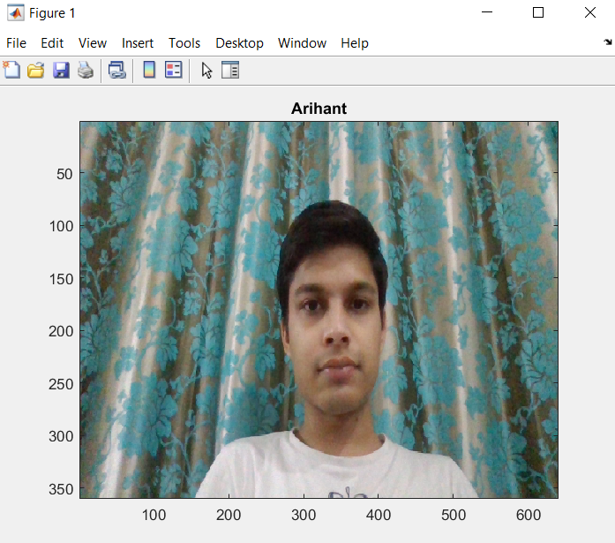
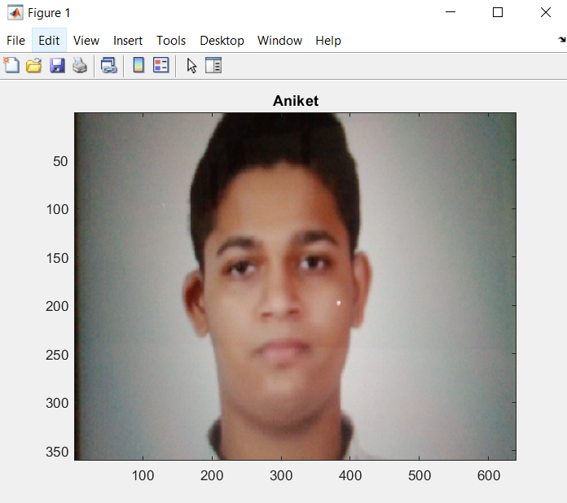
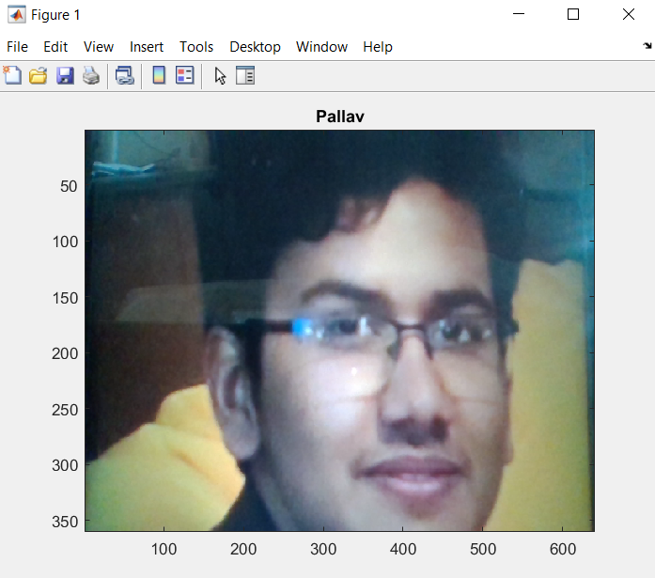

Conclusion
Face detection and recognition technology has experienced some ground-breaking updates in the last two decades. Today, machines are able to automatically verify ownership information through secure transactions, monitoring and security operations, and access control over buildings etc. However, future face recognition programs will have a wide range of applications in smart environments - where computers and equipment are similar to auxiliary assistants.

To achieve this goal computers must be able to reliably identify nearby people in a manner that is naturally consistent within the normal human communication pattern. They should not require special interactions and should be in line with people's understanding of when recognition is possible. This means that future smart environments should use the same methods as humans, and have equal limitations. These goals are now being achieved - however, much research has yet to be done to make human recognition technology work more efficiently, in very different situations using data from one or more methods.

The fully automatic face detection and recognition system which has been implemented with an eye detection system, can be used for surveillance applications such as ATM user security etc. As controlled conditions are present when mugshots are gathered, the frontal view face recognition scheme can give us a recognition accuracy far better than the results which were obtained in this project.
What lies ahead for this technology?
Some experts have predicted that our faces will replace our IDs, credit card pin numbers, passports etc. Given that how convenient, user-friendly and cost-effective this technology is, this prediction is likely to be achieved. If the above stated prediction becomes a reality, any company which implements this technology today, might have high chances of gaining a competitive advantage in the future.

References
- https://towardsdatascience.com/the-intuition-behind-facial-detection-the-viola-jones-algorithm-29d9106b6999
- http://citeseerx.ist.psu.edu/viewdoc/summary?doi=10.1.1.110.4868
- https://towardsdatascience.com/alexnet-the-architecture-that-challenged-cnns-e406d5297951
- https://link.springer.com/referenceworkentry/10.1007%2F978-0-387-73003-5_92
- https://direct.mit.edu/jocn/article/3/1/71/3025/Eigenfaces-for-Recognition
- https://www.researchgate.net/publication/221026665_A_geometric_approach_to_face_recognition
- GitHub - caginozkaya/Face-Detection-And-Recognition-using-Alexnet-and-Viola-Jones-Algorithm-in-Matlab: Alexnet Transfer Learning and Face Detection with CascadeObjectDetector
- GitHub - kalyanghosh/Face-Detection-using-CNN: This repository contains code base for an end to end implementation of a project titled "Face Detection using CNN"

